# Milestone 3

Lauren Matthews

Ashari Joiner

Kellen Edouard

Benito Reyes

1. DFD Diagram 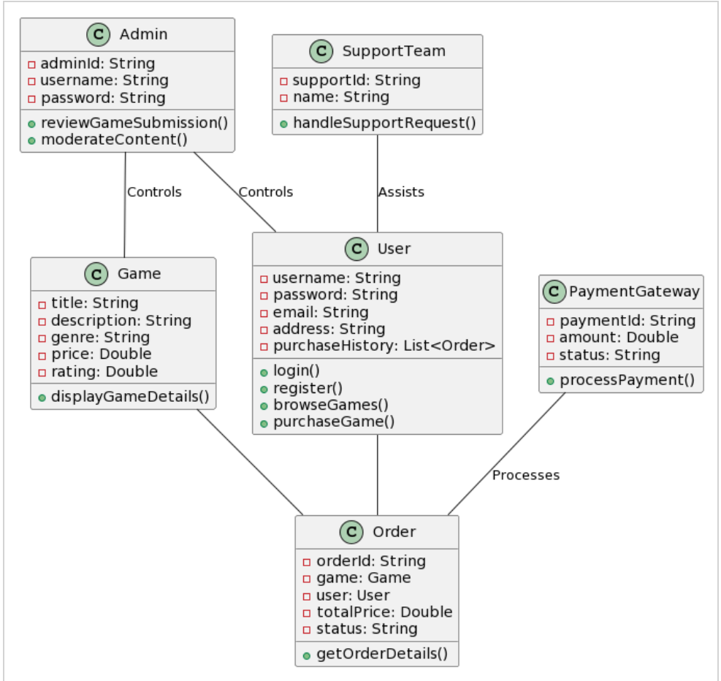

2. Request for Quote

**GameVortex**

**Request For Quotation**

**Reference Number: 19237890**

**March 31, 2024**

3.1.**Statement of Objective**

The objective of this Request for Quotation (RFQ) is to solicit proposals from qualified vendors for the provision of a digital gaming marketplace solution for GameVortex. The solution should align closely with the offerings of platforms like GOG and PlayStation Store, prioritizing a secure and user-friendly environment that enables users to navigate through product listings, make secure transactions, and access their gaming history with ease. The solution should also utilize an API that allows for effective game listings, secure payment processing, and streamlined user interactions, enhancing the overall gaming experience for users while maintaining a commitment to security and accessibility.

**General Conditions**

**2.1. Authorized Representative**

Mr. John Doe

GameVortex

Office of Operational Effectiveness & Procurement Services

1234 Monroe Street

Tallahassee, FL 32301

Approximate Calendar Events

|  |  |
| --- | --- |
| Date | Action |
| 3/31/24 | Request for Quote Advertised |
| 3/31/2024 | Request for Quote Released |
| 4/25/24 | Deadline for submitting questions and/or inquiries in writing only (e-mail) to  [gamevortex@aweu.edu](mailto:gamevortex@aweu.edu) |
| 05/8/24 | Deadline for Game Submission @ 2 PM ET  GameVortex  Office of Operational Effectiveness & Procurement Services  Monroe Building  Tallahassee, FL 32301 |

I. Scope of Work: The vendor is required to provide a comprehensive analysis of the digital gaming marketplace landscape, focusing on platforms like GOG and PlayStation Store. The vendor should evaluate the features, offerings, APIs, and user experiences of these platforms, and how they align with the outlined requirements. The vendor should also consider the APIs of these platforms, their functionalities, and how they can offer a seamless experience for both users and developers. The choice between GOG's API and the PlayStation Network API may hinge on factors such as the target audience, platform compatibility, and specific features required for the digital gaming marketplace, ensuring a tailored solution that meets the unique needs of the system.

II. Location of Work: All work can be done remotely and virtually. No University space or support will be given to complete this work.

III. Period of Performance: Quotes are due on 5/8/2024. Once quotes are reviewed a vendor is selected an evaluation of work development schedule will be set to make sure that the analysis is appropriate and ready on time for the project.

IV. Deliverables Schedule: The required delivery of the analysis is 4/28/2024. The analysis should be presented in a comprehensive report, detailing the findings and recommendations.

V. Applicable Standards: All analysis deliverables and support materials are to be of the highest quality and function flawlessly. A report of specific findings and recommendations needs to be easily accessible to stakeholders. Awesome University reserves the right to refuse payment for work if deliverable is unacceptable.

VI. Acceptable Criteria: The analysis needs to be thorough, covering all relevant aspects of the digital gaming marketplace. It needs to match the specific needs of this project. The analysis needs to be professional, organized, and based on sound research methodology.

VII. Special Requirements: All analysis needs to be easily accessible on the internet.

3.2. Qualification of Bidders

This contract shall be awarded only to a responsive and responsible proposer, qualified to provide the goods and/or service specified. The successful proposer shall, upon request, promptly furnish AWEU sufficient evidence in order to confirm a satisfactory performance record. Such information may include an adequate financial statement of resources, the ability to comply with required or proposed delivery or performance schedule, a satisfactory record of integrity and business ethics, the necessary organization, experience, accounting and operation controls, and technical skills, and be otherwise qualified and eligible to receive an award under applicable laws and regulations.

The proposers must submit the bid using the attached form.

3.3. Award

Awesome University will review and rank every proposal received in response to this RFQ. The most competitive bid that offers the highest level of proven service and reliability will be chosen. AWEU reserves the right to negotiate with the top ranked proposer(s).

3.4. Post Award Meeting

Within five (5) working days after receipt of notification of award of the contract, successful proposer shall meet with the designated AWEU representative(s) at the delivery location to discuss job procedures and scheduling.

3.5. Content Ownership

All content created, not restricted by product copyright, are University property. This includes but is not limited to recordings of the training session.

3.6. Assumptions and Constraints

All developed training needs to be accessible over the web, and qualitative data capture of effectiveness of the training needs to occur. Evaluation and modification of the training is reserved upon the request of Awesome University at any time. The total budget costs are not to exceed 20,000 USD.

3.7. Invoices

All prices must appear in USD and include shipping charges. Service, handling, transaction fees, and tax charges are not applicable as the University’s non-profit tax status. This is a one-time purchase of service and payment terms are NET 60. If selected, for payment to occur all Awesome University vendor paperwork must be submitted to the contact to receive on time payment.

VENDOR INFORMATION

|  |  |
| --- | --- |
| Are you a current Awesome University Approved Vendor? |  |
| References, please list three of your current clients that are similar in scope to this project, that we have permission to contact. |  |

SERVICE CONTRACT

|  |  |  |  |
| --- | --- | --- | --- |
|  | Item Description | Number of Sessions | Price /per session |
| 1. | Trainee One session on signup for company on GameVortex | 2 | $350 |
| 2 | Project Team Member Four sessions on GameVortex setup, with daily update | 4 | $450 |

|  |  |
| --- | --- |
| PLEASE AFFIX SIGNATURE WHERE INDICATED  (FAILURE TO DO SO SHALL RESULT IN THE REJECTION OF YOUR RFQ)  By signature on this document, proposer acknowledges and agrees that its offer includes and accepts all terms, conditions, and specifications of AWEU solicitation as originally published, without exception, change or alteration of any kind, except as may have been published by AWEU in official amendments prior to this date of submittal. | |
| FIRM NAME: (Enter the entire legal name of the proposing entity) | DATE: |
| TELEPHONE # ( )  TOLL FREE # ( )  EMAIL: | PRINT NAME:  PRINT TITLE: |

|  |
| --- |
| ADDRESS: _________________________________________________________________________________________________________  CITY/STATE:_____________________________________________________________  ZIP CODE: _______________________________ |

3. Style Guide

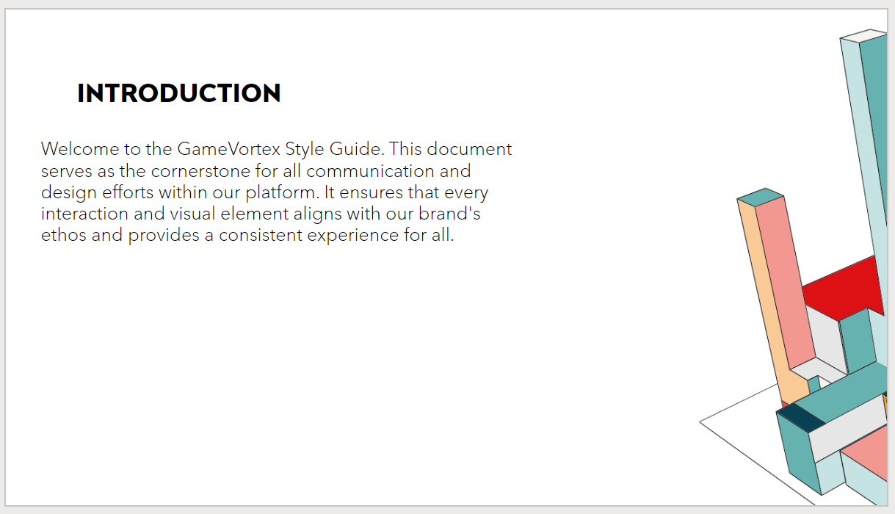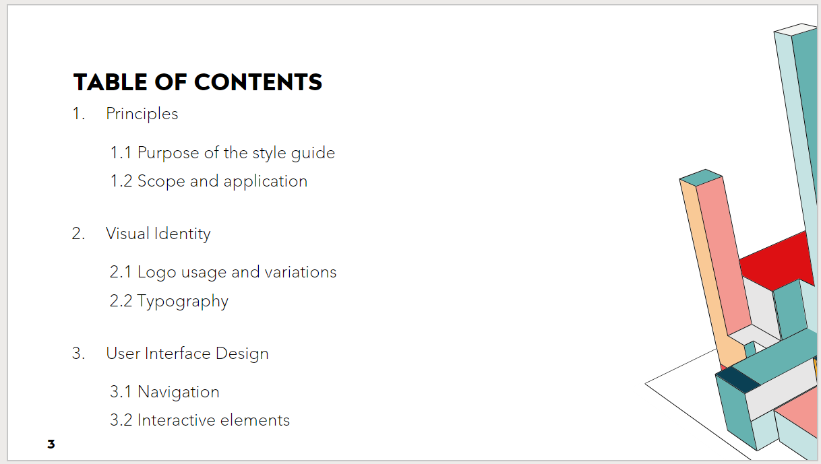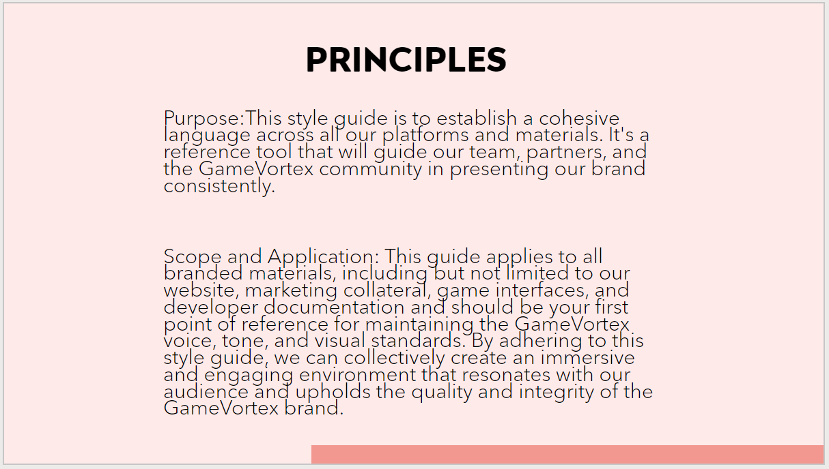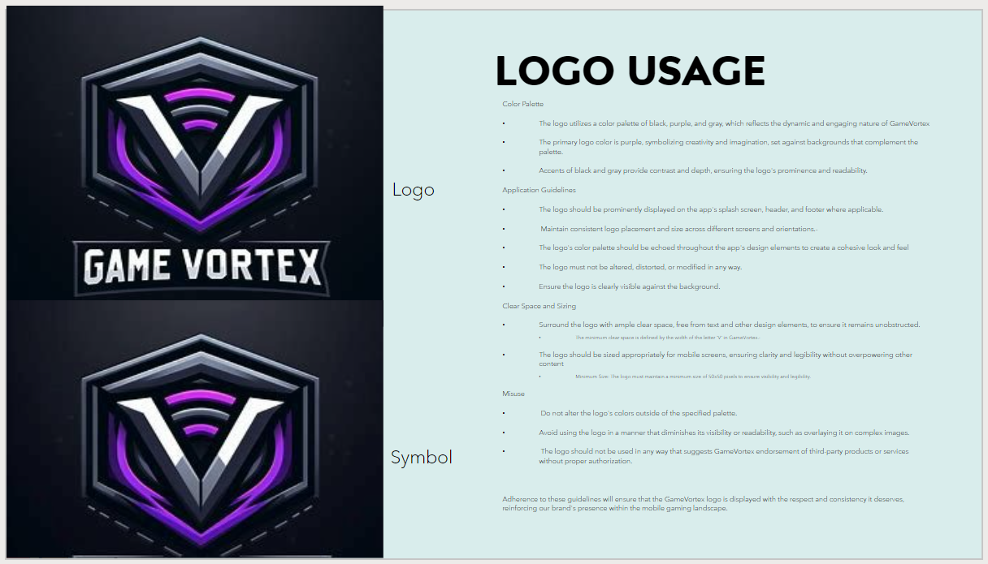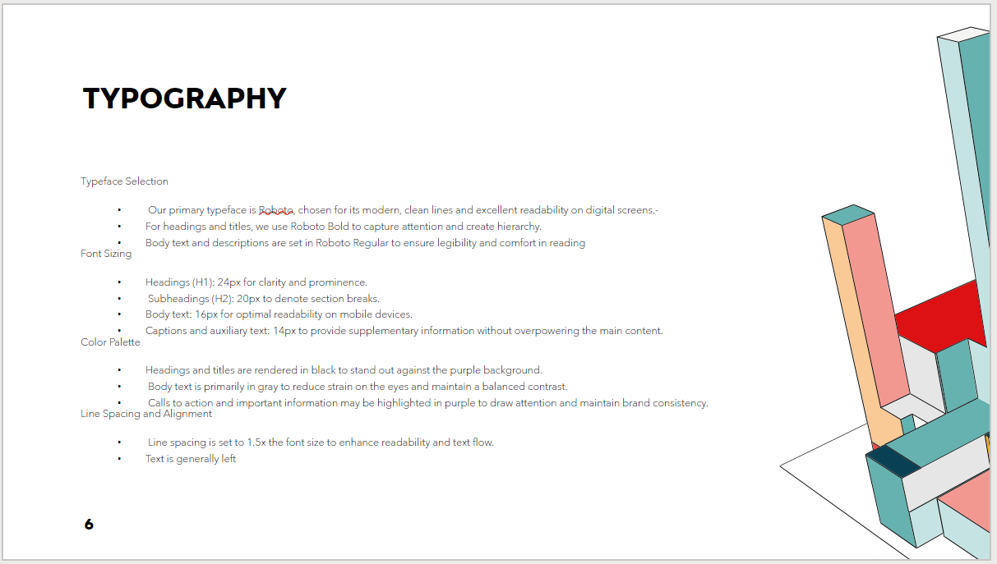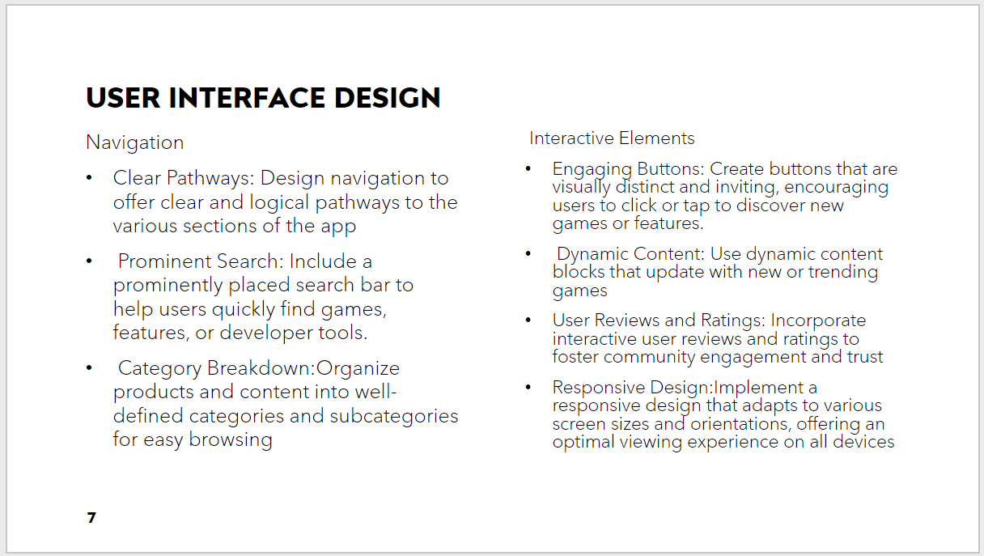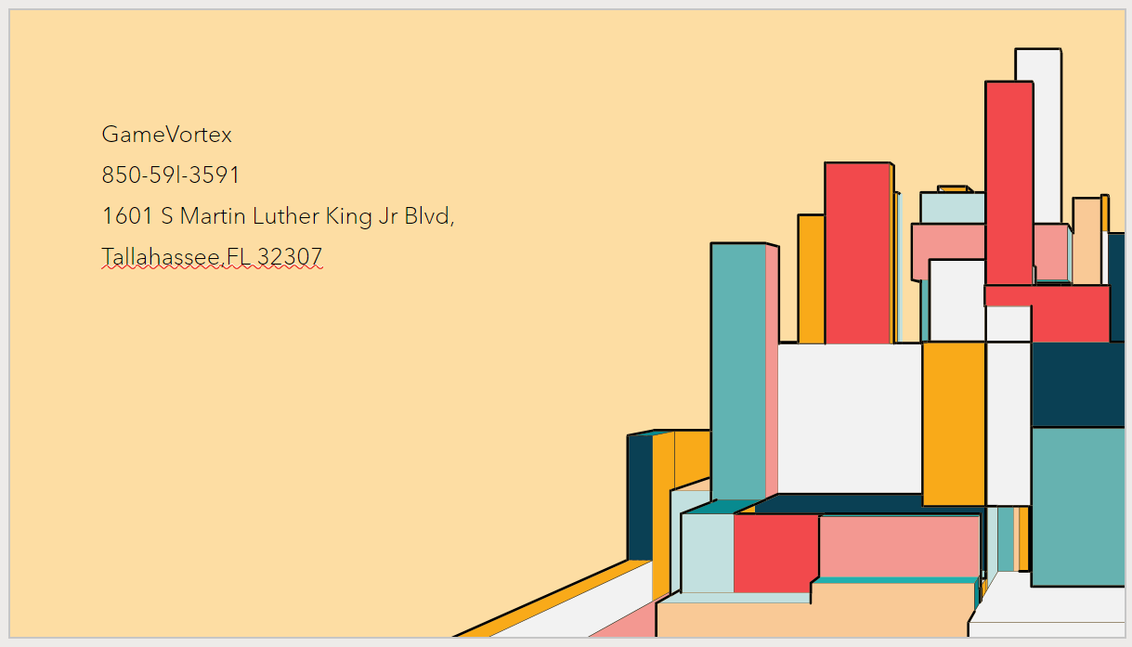4. Interactive Wireframe

<https://www.figma.com/file/Uov0tCqHMUexAXk13dYwt4/Untitled?type=design&node-id=0-1&mode=design>



5. Marketing Material

